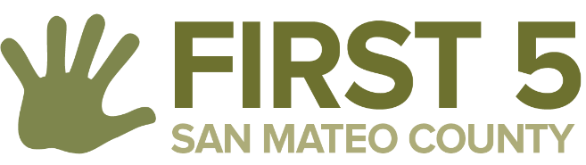

Oral Health Access and Utilization:

Letter of Intent

Instructions: A letter of intent (LOI) is required by all prospective proposers. LOIs are mandatory but not binding. Proposers may elect to change their project model after the submission of an LOI but prior to submission of a full proposal. Should a project model change, the proposer will still be considered eligible for funding. Conversely, there is no penalty for submitting an LOI and then opting out of submitting a full proposal.

LOIs are due no later than March 22, 2021 by 5:00 p.m.

Please have an authorized signatory of your organization sign this Letter of Intent.

Contact Information
Lead Agency Name
Main Contact Name, Title
Street Address
City, State, ZIP Code
Work Phone
E-Mail Address

Brief Description of Intended Project
Please summarize your intended project below and estimated request amount. Explain the project generally including populations to be served, the strategies and activities that will be employed, etc. This project description is non-binding, and Proposers may elect to change their project model prior to submission of a full proposal.

Prospective Collaborations (not mandatory)
Please indicate any known or potential partners you plan to submit a proposal with (if any) and a description of the type of service each partner is likely to provide. This can include entities with which you envision working via MOUs and subcontracts.

Geographic Region Served by Proposing Agency or Collaborative
Please select ALL that apply:
North County (Brisbane, Colma, Daly City, Pacifica, San Bruno, South San Francisco)
Mid County (Belmont, Burlingame, Foster City, Hillsborough, Millbrae, San Carlos, San Mateo)
South County (Atherton, East Palo Alto, Menlo Park, Portola Valley, Redwood City, Woodside)
Coastside (El Granada, Half Moon Bay, Montara, Pescadero)
Other:______________________________________________________________________

Signature
Name (printed)
Signature
Date

Letter of Intent Submission
Thank you for completing this Letter of Intent. Please email your completed Letter of Intent to eroberts@smcgov.org and ecruz@smcgov.org no later than Monday, March 22, 2021 by 5 p.m.

